**Lab#06**

**Summary**

|  |  |
| --- | --- |
| **Items** | **Description** |
| Course Title | Programming Fundamentals |
| Lab Title | Operators in C++ |
| Duration | 3 Hours |
| Operating System/Tool/Language | Ubuntu/ g++/ C++ |
| Objective | To get familiar with use of Conditional Structures |

**CONDITIONAL STRUCTURES (IF ELSE)**

# 1. If-else statement

The if keyword is used to execute a statement or block, if, and only if, a condition is fulfilled. Its syntax is:

if (boolean_expression)

{

// Executes this block if

// condition is true

} else {

// Executes this block if

// condition is false

}

Here, the condition (boolean_expression) is an expression that is being evaluated. If this condition is true, statement is executed. If it is false, the statement in else part is executed.

For example, the following code fragment prints the message (x is 100), only if the value stored in the x variable is indeed 100:

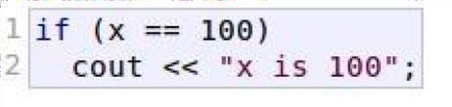

If x is not exactly 100, this statement is ignored, and nothing is printed.

If you want to include more than a single statement to be executed when the condition is fulfilled, these statements shall be enclosed in braces {}, forming a block:

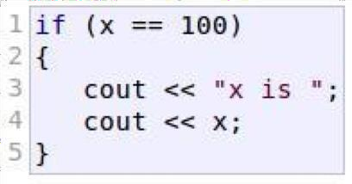

# 2- If-else if Statements

In C/C++ **if-else-if ladder** helps user decide from among multiple options. The C/C++ *if* statements are executed from the top down. As soon as one of the conditions controlling the *if* is true, the statement associated with that *if* is executed, and the rest of the *else- if* ladder is bypassed. If none of the conditions is true, then the final *else* statement will be executed. On the other hand if a sequence of *if*s is used instead of *elseif*, the control goes to every *if* part even if some *if*-part has already been executed.

# Syntax

if (condition) statement 1;

else

if (condition)

statement 2; .

.

else statement;

**Example:**

The sample program below displays the group of person based on age:

# Program

int main(){ int age; cout<< “Enter your age: ”; cin>> age;

if(age<13)

{

cout<< “You are a child”;

}

else if(age<20)

{

cout<< “You are a teenager”;

}

else if(age<40)

{

cout<< “You are still young”;

} else { cout<< “You are senior”;

}

return 0;

}

**LAB TASKS**

## Task#01

Write a C++ code which take three inputs from user, your program should display the smallest value

**Sample Output:**

Enter 1st value = 10

Enter 2nd value = 2

Enter 3rd value = 5

Smallest number = 2

## Task#02

***Note:***

*Use* ***if-else if*** *statements for this program*

Write a program that reads the score of a student in a subject and displays his grades according to the following criteria:

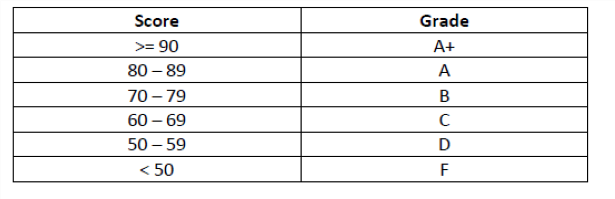

## Task#03

Create a calculator in C++ which can perform addition, subtraction, multiplication, division. .. . Ask the user to enter the operator first then ask the user to enter first and then second value

## Sample Output:

Please enter the operator which you want to perform? + please enter first value? 5 Please enter second value? 6 5+6 =11

## Task#04

Write a program to check whether a triangle is valid or not. The three angles of the triangle are entered through the keyboard. A triangle is valid if the sum of all the three angles is equal to 180 degrees.

## Task#05

A library charges a fine for every book returned late. For first 7 days the fine is 10 PKR, for 8-14 days fine is 20PKR and above 14 days fine is 50PKR. If you return the book after 31 days your membership will be cancelled. Write a program to accept the number of days the member is late to return the book and display the fine or the appropriate message.

## Task#06

Write a program which take a number from the user and display weather the number is even or odd

**Sample Output:** Enter a number? 5

you have entered an odd integer

## Task#07

Write an if statement for the following situation:

If an integer variable **currentNumber** is multiple of 5, change its value so that it is now 3 times currentNumber plus 1, otherwise change its value so that it is now half of **currentNumber**.

## Task#08

Write an if statement that Display “Invalid minutes” to x if the variable minutes is outside the range 0 through 60.